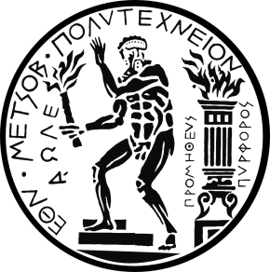

NTUA Workshop
22 April 2016, National Technical University of Athens, Greece

Systems Engineering –

The Art of building ever more complex things.
Regardless of which domain we consider in this modern world, its respective products grow ever more complex. Cars come in a vast number of variants, with many interconnecting devices. Buildings require a huge amount of infrastructure for comfort and convenience which often has to suit a large bandwidth of applications. More complex customer demands and increasing interconnection between digital and physical aspects of product, production and user lead to highly sophisticated systems, made up of a vast number of small pieces of clever engineering and information technology.
How can this complexity be managed? Is there an approach equally valid for domains like automotive, aeronautic, space or civil engineering? Is there a “rocket science“?
And furthermore, how can such systems designed efficiently? Such systems are made up of a number of smaller systems, which are supplied by different companies and designed by different people. How can system architects, -integrators and suppliers work together efficiently, even in the early stages of development?
We will address these questions in a seminar on modern Systems Engineering, which provides methods and processes for safe and secure design and early virtual testing of complex systems. We will touch on important modern aspects, such as model based systems engineering and model based validation as well as agile methods within systems engineering.
Program:
Time | Topic | Presenter
10:30 – 10:40 | Welcoming address | Prof. M. Papadrakakis
10:40 – 10:50 | Presentation of TWT | Dr. M. Keckeisen
10:50 – 11:00 | Presentation of cooperation between TWT and NIKI | Ms. M. Liampoti
11:00 – 11:10 | Working on Automotive Projects | Dr. K. Nicolaou
11:10 – 12:40 | Systems Engineering - The Art of building ever more complex things. | Dr. M.Pfeil  Dr. A. Raufeisen  Dr. M. Keckeisen
12:40 – 13:30 | Short presentations from NTUA Groups | V. Papadopoulos (Civil Eng.)  A. Boudouvis (Chemical Eng.)  K. Giannakoglou (Mechanical Eng.)  C. Provatidis (Mechanical Eng.)  P. Karidis (Naval Eng.)
13:30 – 14:30 | Open forum

